External Project Report on Digital Signal Processing (EET3051)
Dept. of ECE, INSTITUTE OF TECHNICAL EDUCATION AND RESEARCH (FACULTY OF ENGINEERING)
SIKSHA ‘O’ ANUSANDHAN (DEEMED TO BE UNIVERSITY), BHUBANESWAR, ODISHA
i

GUI Based Digital Filter Design Using MATLAB



Submitted by

SHRUTI RAJ - 2341018067

P GOPINATH REDDY - 2341018134

MAHESH KUMAR SAHOO - 2341019194

DECLARATION

We, the undersigned students of Bachelor of Technology in Electronics and Communication Engineering, hereby declare that we take full responsibility for the information, data, and results presented in this project titled “GUI Based Digital Filter Design Using MATLAB”, submitted to Siksha ‘O’ Anusandhan (Deemed to be University), Bhubaneswar, for the partial fulfillment of the subject Digital Signal Processing (EET3051).

We further declare that this project work has been carried out by us under proper guidance and supervision. We have taken due care to respect all intellectual property rights and have acknowledged the contributions of others wherever their work has been referred to for academic purposes. In case of any violation of intellectual property rights or copyright issues, we, as the project members, shall be fully responsible for the same.

NAME | REGISTRATION NUMBER
Shruti Raj | 2341018067
P Gopinath Reddy | 2341018134
Mahesh Kumar Sahoo | 2341019194

Date:
Place: Bhubaneswar, Odisha

CONTENTS

Serial Number | Title of the Chapter | Page Number
1 | Abstract | 4-5
2 | Introduction | 6-8
3 | Problem Statement | 8
4 | Methodology | 9-10
5 | Mathematical Model | 11-12
6 | Implementation | 13-21
7 | Result Analysis | 22-25
8 | Applications | 25
9 | Conclusion | 26
10 | Future Scope | 27
11 | References | 27

Abstract
In the modern digital signal processing (DSP) landscape, the precise isolation of specific frequency bands and the elimination of unwanted noise are fundamental requirements across applications ranging from biomedical instrumentation to audio telephony. Digital filters, particularly Infinite Impulse Response (IIR) filters, are heavily utilized to achieve these goals because they employ feedback mechanisms that allow them to achieve highly steep roll-offs and narrow transition bands with a significantly lower filter order. However, the traditional workflow for designing, analysing, and deploying these IIR filters is largely script-based. Engineers and students are often required to write, debug, and modify extensive lines of code to compare different filter characteristics, manually plot stability charts, and derive the hardware complexity required for physical implementation. This disjointed approach is not only time-consuming but also creates a barrier to intuitively understanding the immediate impact of altering filter parameters.
In this project, we designed and developed an interactive, all-in-one Graphical User Interface (GUI) using MATLAB to streamline the comprehensive design, analysis, and testing of digital IIR filters. The primary objective was to eliminate the repetitive coding bottleneck by creating a responsive visual platform where users can dynamically configure Lowpass, Highpass, Bandpass, and Bandstop filters. By simply inputting key design specifications—such as filter order, cutoff frequency, passband ripple, stopband attenuation, and sampling frequency—the application instantly computes and simultaneously plots the magnitude responses of four distinct IIR filter families: Butterworth, Chebyshev-I, Chebyshev-II, and Elliptic. This allows for immediate comparative analysis of critical trade-offs, such as passband smoothness versus transition band steepness, in a single integrated view.
The system features an automated stability verification tool that maps the calculated coefficients onto a complex Z-plane for pole-zero plot, instantly flagging any unstable filter configurations. Secondly, the GUI includes a dedicated hardware complexity calculator. By selecting a specific filter family and a physical realization structure (Direct Form I or Direct Form II), the tool algorithmically computes the exact number of adders, multipliers, and delay elements required to physically build the filter on hardware. Finally, to validate the designed filters, we integrated a live multi-frequency signal testing module. Users can synthesize a complex input signal by combining different frequency components with varying amplitudes. The system applies the actively designed filter to this composite signal and plots both the original and the filtered waveforms in the time domain, visually demonstrating the successful extraction or suppression of targeted frequencies. The results of our implementation confirm that the GUI successfully unifies the theoretical design, stability analysis, hardware estimation, and practical signal testing into a robust, crash-resistant environment. Ultimately, this tool significantly accelerates the DSP workflow, making it highly suitable for rapid prototyping in embedded systems, telecommunications, and academic research.
Keywords: Digital Signal Processing (DSP), Infinite Impulse Response (IIR), MATLAB GUI, Butterworth, Chebyshev, Elliptic, Pole-Zero Plot, Direct Form Realization, Hardware Complexity, Filter Design.

Introduction

Digital filters are essential in the wider field of digital signal processing applications, such as spectrum analysis, digital image processing, and pattern recognition. In signal processing, the primary function of a filter is to remove unwanted parts of the signal, such as random background noise, or to extract useful parts of the signal lying within a certain frequency range. A digital filter uses a digital processor to perform precise numerical calculations on sampled values of the signal. This mathematical approach eliminates a number of problems associated with their classical analog counterparts, such as component drift and sensitivity to environmental changes, and thus they are increasingly used in place of analog filters.
With the basic building blocks at hand, finite impulse response (FIR) and infinite impulse response (IIR) filters are the two principal techniques utilized for filtering digital signals. Digital filters belong to the class of discrete-time linear time-invariant (LTI) systems. The unit-impulse response sequence of a causal LTI system could be of either finite or infinite duration, and this specific property determines their classification. FIR filters possess no non-zero feedback coefficients; therefore, once the filter has been excited with an impulse, the output is present for only a finite number of computational cycles before settling to zero. Conversely, IIR filters are designed using a feedback structure, meaning their current output is continuously dependent on current inputs, past inputs, and past outputs.
IIR filters stand out because they are highly efficient and can achieve a very steep roll-off—or transition band—with a much lower filter order than their FIR counterparts. Because an IIR filter integrates both a feed-forward polynomial (where the roots represent the zeros) and a feedback polynomial (where the roots represent the poles), it yields a much sharper transition characteristic for a given filter order. Furthermore, IIR filters have traditional analog counterparts—namely Butterworth, Chebyshev (Type I and II), Elliptic, and can be synthesized using familiar analog filter design techniques mapped into the digital domain via methods like the bilinear transformation and Impulse Invariant Transformation. Different IIR families serve different purposes; for instance, Butterworth filters offer a perfectly smooth passband, while Elliptic filters provide the sharpest possible cut-off to tightly band-limit signals. Due to their reliance on feedback, IIR filters involve significantly less computational complexity, demanding fewer mathematical operations, which ultimately saves memory, reduces power consumption, and makes them faster than FIR filters.
While the mathematical foundation of these digital filters is robust, implementing and analysing them practically requires accessible software tools. A Graphical User Interface (GUI) in MATLAB provides an environment that allows users to interact with complex digital signal processing algorithms using visual components like buttons, dropdowns, and plots, rather than repeatedly typing code. In this project, the GUI is built programmatically using MATLAB's App Designer framework, utilizing tools like uifigure and uigridlayout to create a modern layout. This relies on an event-driven architecture; user interactions trigger specific callback functions that extract UI states, execute underlying DSP logic, and dynamically update axes and status labels in real-time without requiring a system restart.
Literature Survey:
The development of digital filter design has evolved significantly over the past half-century, transitioning from purely mathematical derivations to accessible, software-driven implementations. Early foundational work, such as that by Herrmann (1970), focused on developing methods for designing optimal FIR filters by assuming equiripple frequency responses in both the passband and stopband regions. As computational capabilities expanded, researchers began integrating these mathematical models into user-friendly software environments to streamline the design process. Rahman Jamal et al. (1996) demonstrated the utility of graphical interfaces by designing filters using dedicated toolkits within LabVIEW software, highlighting a broader industry shift toward visual design tools. Following this trajectory into MATLAB-based environments, Timothy J. Schlichter (1999) explored the foundational digital filter design options available within the software, providing practical baseline examples for synthesizing basic lowpass, highpass, and bandpass configurations.
More recent literature emphasizes the practical, interactive implementation and real-world deployment of digital filters. Ricardo A. Losada (2004) addressed the practical aspects of filter design and fixed-point implementation using algorithms available in MATLAB's Signal Processing Toolbox. Building directly upon these interactive frameworks, Zena Ez Dallalbashi (2020) proposed a comprehensive PC-based digital filter implementation utilizing MATLAB's Graphical User Interface (GUI), which featured a unified front panel for controlling parameters and actively analysing both FIR and IIR filtering techniques. While these prior studies establish a strong precedent for GUI-based signal processing, existing tools often focus strictly on isolated magnitude response plotting or basic noise cancellation. There remains a notable gap for a fully integrated environment that simultaneously compares multiple IIR filter families (Butterworth, Chebyshev, and Elliptic), automatically verifies system stability via Z-plane pole-zero mapping, and explicitly calculates the hardware complexity for physical realizations—which is exactly the void this project addresses.
Despite these advancements, most existing implementations focus purely on the mathematical plotting of magnitude responses or basic noise cancellation. They often lack an all-in-one integrated environment that seamlessly bridges theoretical DSP mathematics with physical hardware estimation and real-world multifrequency signal testing. This gap—the lack of an integrated, automated tool for stability analysis, hardware block realization, and immediate signal processing validation in a single interactive window—is what our project attempts to address.
The objective of this project is to:
- Develop an interactive MATLAB graphical interface capable of designing Lowpass, Highpass, Bandpass, and Bandstop IIR filters.
- Compare the magnitude response of Butterworth, Chebyshev-I, Chebyshev-II, and Elliptic Filters simultaneously.
- Analyse the stability of the generated filters automatically by mapping a pole-zero plot on the complex Z-plane.
- Calculate the specific number of Adders, Multipliers, and Delay blocks required for the physical hardware realization of these filters in Direct Form I and II structures.
- Test the designed filters directly on multi-frequency signals to observe and validate their filtering capabilities in simulated real-world conditions.
- Problem Statement

In the field of digital signal processing, designing and implementing Infinite Impulse Response (IIR) filters involves complex mathematical computations and rigorous stability verification. Traditionally, researchers and students must write extensive, repetitive code to generate and compare the magnitude responses of different filter families, such as Butterworth, Chebyshev-I, Chebyshev-II, and Elliptic filters. This manual, script-based approach creates a significant bottleneck when attempting to perform instant comparative analysis or when actively analyzing the stability of the generated filters using pole-zero plots.
The primary problem this project solves is the lack of a unified, interactive environment. It asks: How can we eliminate the need for repetitive coding by developing a single Graphical User Interface (GUI) that instantly integrates complex filter design, automated stability verification, hardware complexity estimation, and real-time signal testing?

- Methodology

- Parameter Extraction and Normalization
The system begins by capturing user-defined filter specifications from the GUI, including Filter Type, Filter Order (N), absolute Cutoff Frequency (fc), Passband Ripple (Rp), Stopband Attenuation (Rs), and Sampling Frequency (Fs). To process these digitally, the absolute cutoff frequencies are converted into normalized digital frequencies (Wn) based on the Nyquist rate, ensuring the parameters are scaled between 0 and 1 for algorithmic processing (Wn = fc / (Fs / 2)).
- IIR Filter Coefficient Generation
Using the normalized specifications, the system computes the discrete transfer function coefficients. It simultaneously triggers MATLAB’s core signal processing approximation algorithms (butter, cheby1, cheby2, ellip). These functions map traditional analog filter characteristics into the digital domain (typically via bilinear transformation internally), outputting the numerator coefficients (b_{k}) representing the zeros, and the denominator coefficients (a_{k}) representing the poles for all four filter families. An IIR filter can be represented as,
$y\left(n\right)=\sum_{k=0}^{M}{b_{k} x\left(n-k\right)} - \sum_{k=1}^{N}{a_{k} y\left(n-k\right)}$
- Frequency Response Analysis
To visually compare the performance of the generated filters, the system calculates the frequency response of each filter over a set of frequency points using the freqz function. The complex magnitude of the frequency response is converted into decibels ($20\log_{10}\left|H\right|$) and plotted against the frequency axis. This allows for an immediate, side-by-side graphical comparison of critical DSP trade-offs, such as passband flatness (Butterworth) versus transition band steepness (Elliptic).
- Automated Stability Verification
An IIR filter is inherently at risk of instability due to its feedback mechanism. The system performs automated stability analysis by extracting the roots of the denominator polynomial to locate the system's poles, and the roots of the numerator polynomial to locate the zeros. These are plotted on the complex Z-plane using the zplane() function. Furthermore, the system computationally evaluates whether the absolute magnitude of all poles is strictly less than 1. If any pole falls on or outside the unit circle, the GUI automatically flags the filter as unstable.
- Hardware Complexity Estimation
To bridge the gap between mathematical design and physical hardware implementation (such as on an FPGA or DSP chip), the system calculates the required structural components. Based on the selected filter family and the filter order (N), the algorithm computes the exact number of adders, multipliers, and unit delay elements (Z⁻¹) needed to realize the filter's difference equation. It actively differentiates between Direct Form I (which uses separate delay lines for inputs and outputs) and Direct Form II (which shares a canonical delay line to minimize memory usage).
Let a represent the order of the numerator polynomial and b represent the order of the denominator polynomial of IIR filter transfer function in Z – domain. Then,
For Direct Form 1 Structure:
No. Of Adders = a + b
No. of Multipliers = a + b + 1
No. of Delay units = a + b
For Direct Form 2 Structure:
No. Of Adders = a + b
No. of Multipliers = a + b + 1
No. of Delay units = Max ( a , b )
- Time-Domain Signal Synthesis and Filtering
To validate the filter practically, the system includes a signal testing module. It basically takes a signal with multiple frequency and amplitude, then applies the designed filter to the input signal. Mathematically it can be represented as
$x\left(n\right)= \sum_{i=0}^{M}{{ A}_{i}\sin\left(2πf_{i}t\right)}$
Where M = No of Frequency component present in the signal
Once the complex multi-frequency input signal is generated, the selected IIR filter coefficients are applied to it using the standard linear constant-coefficient difference equation via MATLAB's filter function. Both the original composite signal and the resulting filtered signal are plotted in the time domain to visually confirm the successful extraction or attenuation of the targeted frequency bands.

- Mathematical Model
The IIR filters use feedback, meaning their current output depends on current inputs, past inputs, and past outputs. So, an IIR digital filter can be represented by the linear constant coefficient difference equation as,
$$y\left(n\right)=\sum_{k=0}^{M}{b_{k} x\left(n-k\right)} - \sum_{k=1}^{N}{a_{k} y\left(n-k\right)}$$
Where, x(n) = input signal
y(n) = output signal / filtered signal
a_{k} = Feedback coefficient
b_{k} = Feed Forward coefficient
N = Order of denominator polynomial
M = Order of numerator polynomial
Now if we apply the Z-transform on the above difference equation we will get a transfer function as,
$$H\left(z\right)=\frac{Y\left(z\right)}{X\left(z\right)}=\frac{\sum_{k=0}^{M}{b_{k}z^{-k}}}{\sum_{k=1}^{N}{a_{k}z^{-k}}}$$
By simplifying the numerator and denominator polynomial we will get the transfer function as
$H\left(z\right)= \frac{b_{0}+b_{1}z^{-1}+…+b_{M}z^{-M}}{a_{0}+a_{1}z^{-1}+…+a_{N}z^{-N}}$
Now this transfer function plays a vital role in determining the stability of the filter. Because the roots of numerator polynomial are the zeros of the system where as the roots of denominator polynomial are the poles of the system. Now, if all the poles lie within the unit circle of Z-plane, then the system is stable otherwise if all the poles lie outside of the unit circle, then the system is unstable.
We can also write the output or response of the filter as
y(n) = x(n) * h(n)
where h(n) is the impulse response of the filter which can be obtained by taking the inverse Z-transform of the transfer function H(z).
$h\left(n\right)= z^{-1}[H\left(z\right)]$
To observe the magnitude response the IIR filter we need to use discrete time Fourier transformation (DTFT) on the transfer function H(z) to plot its magnitude and phase response.
It is given by, ${H(e}^{jω})=H\left(z\right)|_{z=e^{jω}}$

Or ${H(e}^{jω})=\sum_{n=-∞}^{∞}{h\left(n\right)e^{jωn}}$
Now the magnitude of the filter is given by |${ H(e}^{jω})$ | = 20$\log{{H(e}^{jω})}$
IIR Filter Design Parameters:
To design a IIR filter we need to follow some basic steps in which we will define different filter parameters so that a filter can be designed according to our need. These parameters are defined on the basis of analog filter characteristics, because at last we want to implement a analog filter in a digital processor so that we can use them to apply on digital signal data. The parameters are as follows:
Rp = Passband ripple parameter (in dB)
As = stopband attenuation parameter (in dB)
Ωp = Passband cutoff frequency
Ωs = Stopband cutoff frequency
Fs = sampling frequency
Now digital frequency can be determined by the formula
ω_{p} = $\frac{Ωp}{Fs/2}$ ω_{s} = $\frac{Ωs}{Fs/2}$

Implementation

Block Diagram:

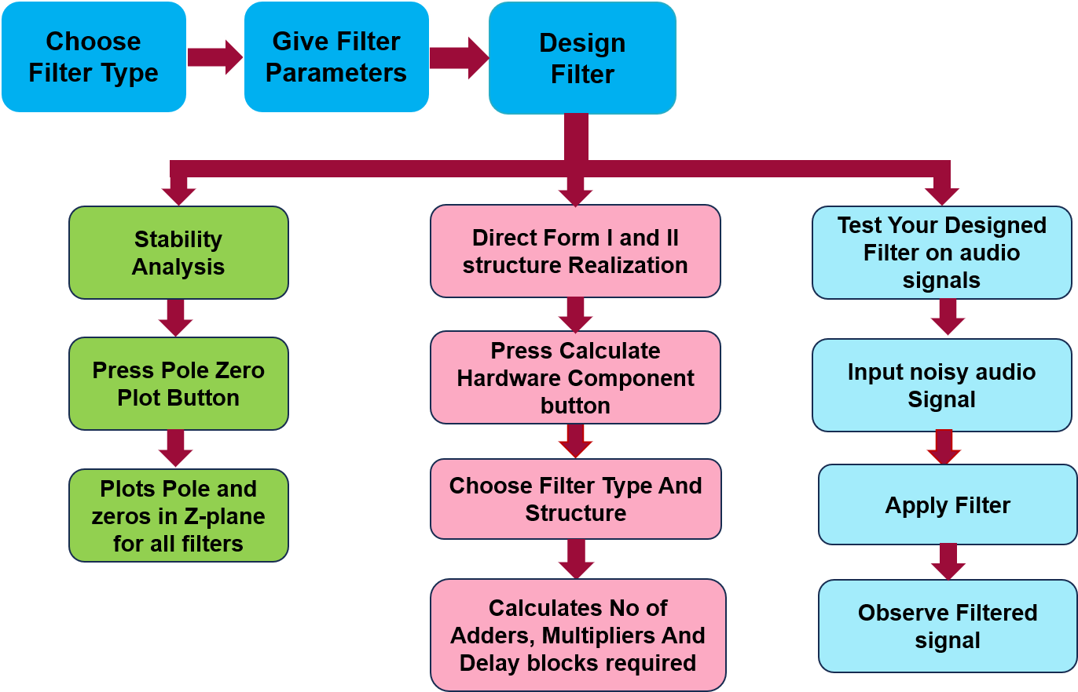
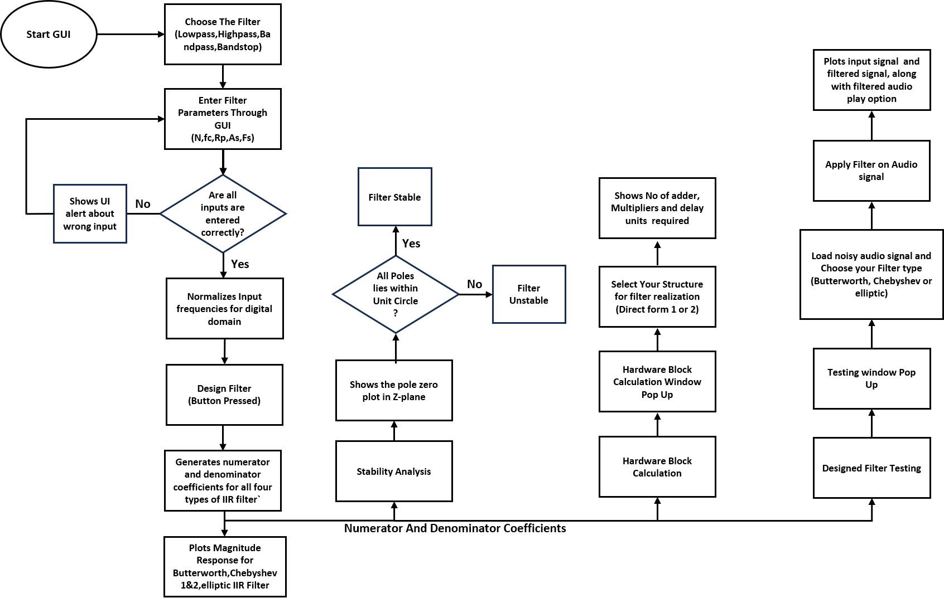
Operational Workflow of the Filter Design Tool
( Workflow of Entire Digital Filter GUI )
MATLAB Program

function IIR_FILTER_GUI
% Name: Mahesh Kumar Sahoo
% Reg No: 2341019194

clc;clear;close all;

% Shared variables to store coefficients for the Pole-Zero plot and Filtering
b1 = []; a1 = [];
b2 = []; a2 = [];
b3 = []; a3 = [];
b4 = []; a4 = [];
filtersDesigned = false; % Flag to check if filters are generated

% MAIN WINDOW
fig = uifigure('Name', 'IIR Filter Design','Position', [100 100 950 600]);

% MAIN GRID
main_grid = uigridlayout(fig, [1, 2]);
main_grid.ColumnWidth = {'1x', '1.5x'};

% LEFT PANEL
left_grid = uigridlayout(main_grid, [15, 2]); % Increased rows to 13
left_grid.RowHeight = {25,25,25,25,25,25,40,40,40,40,30,30,'1x'}; % Added height for new button
left_grid.ColumnWidth = {150,'1x'};
left_grid.Padding = [10 10 10 10];

% FILTER TYPE
uilabel(left_grid, 'Text', 'Filter Type:');
typeDrop = uidropdown(left_grid,'Items', {'Lowpass', 'Highpass', 'Bandpass', 'Bandstop'});

% FILTER ORDER
uilabel(left_grid, 'Text', 'Filter Order (N):');
orderEdit = uieditfield(left_grid,'numeric', 'Value', 4);

% CUTOFF
uilabel(left_grid, 'Text', 'Cutoff Freq:');
cutoffEdit = uieditfield(left_grid,'text','Placeholder', 'e.g. 200 or 100 300 (Enter in Hz)');

% PASSBAND RIPPLE
uilabel(left_grid, 'Text', 'Passband Ripple:');
rpEdit = uieditfield(left_grid,'numeric','Value', 1, 'Placeholder', 'Enter in dB');

% STOPBAND ATTENUATION
uilabel(left_grid, 'Text', 'Stopband Attenuation:');
rsEdit = uieditfield(left_grid,'numeric','Value', 40, 'Placeholder', 'Enter in dB');

% SAMPLING FREQUENCY
uilabel(left_grid, 'Text', 'Sampling Freq:');
fsEdit = uieditfield(left_grid,'numeric','value', 1000,'Placeholder', 'Enter in Hz');

% DESIGN BUTTON
designBtn = uibutton(left_grid,'Text', 'Design Filters','ButtonPushedFcn', @(btn,event) designFilter());
designBtn.Layout.Row = 7;
designBtn.Layout.Column = [1 2];
designBtn.BackgroundColor = [0 0.4470 0.7410];
designBtn.FontColor = [1 1 1];
designBtn.FontWeight = 'bold';

% POLE-ZERO BUTTON
pzBtn = uibutton(left_grid,'Text', 'Show Pole-Zero Plot','ButtonPushedFcn', @(btn,event) plotPoleZero());
pzBtn.Layout.Row = 8;
pzBtn.Layout.Column = [1 2];
pzBtn.BackgroundColor = [0.4660 0.6740 0.1880]; % MATLAB Green
pzBtn.FontColor = [1 1 1];
pzBtn.FontWeight = 'bold';

% HARDWARE CALCULATOR BUTTON
hwBtn = uibutton(left_grid, 'Text', 'Calculate Hardware Components', 'ButtonPushedFcn', @(btn,event) calcHardware());
hwBtn.Layout.Row = 9;
hwBtn.Layout.Column = [1 2];
hwBtn.BackgroundColor = [0.8500 0.3250 0.0980]; % MATLAB Orange
hwBtn.FontColor = [1 1 1];
hwBtn.FontWeight = 'bold';

% SIGNAL FILTERING TEST BUTTON (NEW)
testSigBtn = uibutton(left_grid, 'Text', 'Test Filter on Signal', 'ButtonPushedFcn', @(btn,event) testSignalFilter());
testSigBtn.Layout.Row = 10;
testSigBtn.Layout.Column = [1 2];
testSigBtn.BackgroundColor = [0.4940 0.1840 0.5560]; % MATLAB Purple
testSigBtn.FontColor = [1 1 1];
testSigBtn.FontWeight = 'bold';

% STATUS LABEL
statusLabel = uilabel(left_grid, 'Text','Status : Waiting','FontWeight','bold','FontSize',13);
statusLabel.Layout.Row = 11;
statusLabel.Layout.Column = [1 2];

% Computation Time
timeLabel = uilabel(left_grid, 'Text','Time consumed for :','FontWeight','bold','FontSize',13);
timeLabel.Layout.Row = [12 15];
timeLabel.Layout.Column = [1 2];

% AXES
ax = uiaxes(main_grid);
ax.Layout.Row = 1;
ax.Layout.Column = 2;
ax.FontSize = 12;
grid(ax,'on');
xlabel(ax,'Frequency (Hz)');
ylabel(ax,'Magnitude (dB)');
title(ax,'Comparison of IIR Filters');

% DESIGN FILTER FUNCTION

function designFilter()
try
n = orderEdit.Value;
fc = str2num(cutoffEdit.Value);
Rp = rpEdit.Value;
Rs = rsEdit.Value;
Fs = fsEdit.Value;
filterType = typeDrop.Value;

if isempty(fc)
uialert(fig, 'Please enter cutoff frequency.', 'Input Error');
return;
end

if ((filterType == convertCharsToStrings('Bandpass')) || (filterType == convertCharsToStrings('Bandstop'))) && isscalar(fc)
uialert(fig, 'Please enter cutoff frequency as f1 f2 (e.g. 100 200, in Hz) for bandpass and bandstop filter', 'Input Error');
return;
end

Wn = fc/(Fs/2);
cla(ax);
hold(ax,'on');

t_butt = 0; t_cheby1 = 0; t_ellip = 0; t_cheby2 = 0;

switch filterType
case 'Lowpass'
t = tic; [b1,a1] = butter(n,Wn,'low'); t_butt = toc(t);
t = tic; [b2,a2] = cheby1(n,Rp,Wn,'low'); t_cheby1 = toc(t);
t = tic; [b3,a3] = ellip(n,Rp,Rs,Wn,'low'); t_ellip = toc(t);
t = tic; [b4,a4] = cheby2(n,Rp,Wn,'low'); t_cheby2 = toc(t);
case 'Highpass'
t = tic; [b1,a1] = butter(n,Wn,'high'); t_butt = toc(t);
t = tic; [b2,a2] = cheby1(n,Rp,Wn,'high'); t_cheby1 = toc(t);
t = tic; [b3,a3] = ellip(n,Rp,Rs,Wn,'high'); t_ellip = toc(t);
t = tic; [b4,a4] = cheby2(n,Rp,Wn,'high'); t_cheby2 = toc(t);
case 'Bandpass'
t = tic; [b1,a1] = butter(n,Wn); t_butt = toc(t);
t = tic; [b2,a2] = cheby1(n,Rp,Wn); t_cheby1 = toc(t);
t = tic; [b3,a3] = ellip(n,Rp,Rs,Wn); t_ellip = toc(t);
t = tic; [b4,a4] = cheby2(n,Rp,Wn); t_cheby2 = toc(t);
case 'Bandstop'
t = tic; [b1,a1] = butter(n,Wn,'stop'); t_butt = toc(t);
t = tic; [b2,a2] = cheby1(n,Rp,Wn,'stop'); t_cheby1 = toc(t);
t = tic; [b3,a3] = ellip(n,Rp,Rs,Wn,'stop'); t_ellip = toc(t);
t = tic; [b4,a4] = cheby2(n,Rp,Wn,'stop'); t_cheby2 = toc(t);
end

%cell array of strings for a multi-line label
timeText = {
'Time consumed for filter coefficient calculation of :';
sprintf('Butterworth : %.5f s', t_butt);
sprintf('Chebyshev-I : %.5f s', t_cheby1);
sprintf('Elliptic : %.5f s', t_ellip);
sprintf('Chebyshev-II : %.5f s', t_cheby2)
};

% Assign it to the label you created earlier
timeLabel.Text = timeText;
timeLabel.FontColor = [0.2, 0.35, 0.5];

% Set flag to true so other buttons work
filtersDesigned = true;

[H1,f] = freqz(b1,a1,1024,Fs);
[H2,~] = freqz(b2,a2,1024,Fs);
[H3,~] = freqz(b3,a3,1024,Fs);
[H4,~] = freqz(b4,a4,1024,Fs);

plot(ax,f,20*log10(abs(H1)), 'LineWidth',2);
plot(ax,f,20*log10(abs(H2)), 'LineWidth',2);
plot(ax,f,20*log10(abs(H3)), 'LineWidth',2);
plot(ax,f,20*log10(abs(H4)), 'LineWidth',0.7);

legend(ax, 'Butterworth', 'Chebyshev-I', 'Elliptic','Chebyshev-II', 'Location','best');
title(ax, ['Comparison of ' filterType ' Filters']);
xlabel(ax,'Frequency (Hz)');
ylabel(ax,'Magnitude (dB)');
grid(ax,'on');

if all(abs(roots(a1)) < 1) && all(abs(roots(a2)) < 1) && all(abs(roots(a3)) < 1) && all(abs(roots(a4)) < 1)
statusLabel.Text = 'Status : All Filters are Stable';
statusLabel.FontColor = [0 0.5 0.1];
else
statusLabel.Text = 'Status : Unstable Filter Found';
statusLabel.FontColor = [1 0 0];
end
catch ME
uialert(fig, ME.message, 'Design Error');
end
end
% POLE-ZERO PLOT FUNCTION
function plotPoleZero()
if ~filtersDesigned
uialert(fig, 'Please design the filters first by clicking "Design Filters".', 'Missing Data');
return;
end

pzFig = figure('Name','Pole-Zero Analysis', 'Position', [500 200 550 500]);

subplot(2,2,1);
zplane(b1,a1);
title('Butterworth');

subplot(2,2,2);
zplane(b2,a2);
title('Chebyshev-I');

subplot(2,2,3);
zplane(b4,a4); % Fixed this to correctly plot Chebyshev-II
title('Chebyshev-II');

subplot(2,2,4);
zplane(b3,a3);
title('Elliptic');
end

% HARDWARE CALCULATOR FUNCTION

function calcHardware()
if ~filtersDesigned
uialert(fig, 'Please design the filters first by clicking "Design Filters".', 'Missing Data');
return;
end

% Create modal window for selections
hwFig = uifigure('Name', 'Hardware Complexity', 'Position', [350 250 350 300], 'WindowStyle', 'modal');
hwGrid = uigridlayout(hwFig, [5, 2]);
hwGrid.RowHeight = {30, 30, 40, 90, '1x'};

uilabel(hwGrid, 'Text', 'Structure:');
structDrop = uidropdown(hwGrid, 'Items', {'Direct Form I', 'Direct Form II'});

uilabel(hwGrid, 'Text', 'Filter:');
filtDrop = uidropdown(hwGrid, 'Items', {'Butterworth', 'Chebyshev-I', 'Elliptic','Chebyshev-II'});

calcActionBtn = uibutton(hwGrid, 'Text', 'Calculate', 'ButtonPushedFcn', @(btn,event) showHardwareBlocks());
calcActionBtn.Layout.Row = 3;
calcActionBtn.Layout.Column = [1 2];

resLabel = uilabel(hwGrid, 'Text', '', 'WordWrap', 'on', 'FontWeight', 'bold');
resLabel.Layout.Row = 4;
resLabel.Layout.Column = [1 2];

function showHardwareBlocks()
strType = structDrop.Value;
fType = filtDrop.Value;

if strcmp(fType, 'Butterworth')
num = b1; den = a1;
elseif strcmp(fType, 'Chebyshev-I')
num = b2; den = a2;
elseif strcmp(fType, 'Chebyshev-II')
num = b4; den = a4;
else
num = b3; den = a3;
end

N_num = length(num) - 1;
M_den = length(den) - 1;

adders = N_num + M_den;
multipliers = N_num + 1 + M_den;

if strcmp(strType, 'Direct Form I')
delays = N_num + M_den;
else
delays = max(N_num, M_den);
end

resultText = sprintf('Structure: %s\nFilter: %s\n\nAdders Required: %d\nMultipliers Required: %d\nDelay Elements Required: %d', ...
strType, fType, adders, multipliers, delays);
resLabel.Text = resultText;
end
end
% SIGNAL FILTERING TEST FUNCTION (AUDIO INPUT)
function testSignalFilter()
if ~filtersDesigned
uialert(fig, 'Please design the filters first by clicking "Design Filters".', 'Missing Data');
return;
end

% Variables to store audio data locally within this function
audioData = [];
filteredAudio = [];
audioFs = 44100; % Default, will be updated on load

% Create new larger window for signal processing
sigFig = uifigure('Name', 'Audio Filtering', 'Position', [200 100 800 650]);

% Create a 5-row, 5-column grid to strictly control button sizes
sigGrid = uigridlayout(sigFig, [5, 5]);
sigGrid.RowHeight = {40, '1x', 30, '1x', 30};
sigGrid.ColumnWidth = {'1x', 140, 160, 140, '1x'};

% --- ROW 1: Controls ---
loadBtn = uibutton(sigGrid, 'Text', 'Load Audio File', 'ButtonPushedFcn', @(btn,event) loadAudioFile());
loadBtn.Layout.Row = 1; loadBtn.Layout.Column = 2;

filtApplyDrop = uidropdown(sigGrid, 'Items', {'Butterworth', 'Chebyshev-I','Chebyshev-II', 'Elliptic'});
filtApplyDrop.Layout.Row = 1; filtApplyDrop.Layout.Column = 3;

runFilterBtn = uibutton(sigGrid, 'Text', 'Filter Audio', 'ButtonPushedFcn', @(btn,event) applyAudioFilter());
runFilterBtn.BackgroundColor = [0.8500 0.3250 0.0980];
runFilterBtn.FontColor = 'white';
runFilterBtn.FontWeight = 'bold';
runFilterBtn.Layout.Row = 1; runFilterBtn.Layout.Column = 4;

% --- ROW 2: Original Audio Plot ---
axNoisy = uiaxes(sigGrid);
axNoisy.Layout.Row = 2;
axNoisy.Layout.Column = [1 5];
title(axNoisy, 'Original Audio Signal');
xlabel(axNoisy, 'Time (s)');
ylabel(axNoisy, 'Amplitude');
grid(axNoisy, 'on');

% --- ROW 3: Play Original Audio Button ---
% Placed in column 3 to center it, inherently making it a smaller, fixed width
playOrigBtn = uibutton(sigGrid, 'Text', 'Play original audio', 'ButtonPushedFcn', @(btn,event) playSound('original'));
playOrigBtn.Layout.Row = 3;
playOrigBtn.Layout.Column = 3;
playOrigBtn.Enable = 'off';

% --- ROW 4: Filtered Audio Plot ---
axFilt = uiaxes(sigGrid);
axFilt.Layout.Row = 4;
axFilt.Layout.Column = [1 5];
title(axFilt, 'Filtered Audio Signal');
xlabel(axFilt, 'Time (s)');
ylabel(axFilt, 'Amplitude');
grid(axFilt, 'on');

% --- ROW 5: Play Filtered Audio Button ---
playFiltBtn = uibutton(sigGrid, 'Text', 'Play filtered audio', 'ButtonPushedFcn', @(btn,event) playSound('filtered'));
playFiltBtn.Layout.Row = 5;
playFiltBtn.Layout.Column = 3;
playFiltBtn.Enable = 'off';

% NESTED FUNCTIONS FOR AUDIO PROCESSING
function loadAudioFile()
[file, path] = uigetfile({'*.wav;*.mp3;*.m4a;*.ogg', 'Audio Files (*.wav, *.mp3, *.m4a, *.ogg)'}, 'Select an Audio File');
if isequal(file, 0)
return; % User canceled
end

try
[audioData, audioFs] = audioread(fullfile(path, file));

% Convert to mono if it is a stereo audio file
if size(audioData, 2) > 1
audioData = mean(audioData, 2);
end

% Plot Original Audio
t = (0:length(audioData)-1) / audioFs;
plot(axNoisy, t, audioData, 'Color', [0.8 0.2 0.2]);
title(axNoisy,'Original Audio With Noise');
xlim(axNoisy, [0 max(t)]);

% Update Buttons
playOrigBtn.Enable = 'on';
playFiltBtn.Enable = 'off';
cla(axFilt); % Clear lower plot until filtered

catch ME
uialert(sigFig, ['Error loading audio: ' ME.message], 'Load Error');
end
end

function applyAudioFilter()
if isempty(audioData)
uialert(sigFig, 'Please load an audio file first.', 'Missing Data');
return;
end

fApplyType = filtApplyDrop.Value;

% Select coefficients based on dropdown
if strcmp(fApplyType, 'Butterworth')
num = b1; den = a1;
elseif strcmp(fApplyType, 'Chebyshev-I')
num = b2; den = a2;
elseif strcmp(fApplyType, 'Chebyshev-II')
num = b4; den = a4;
else
num = b3; den = a3;
end

try
% Apply the designed filter
filteredAudio = filter(num, den, audioData);

% Plot Filtered Audio
t = (0:length(filteredAudio)-1) / audioFs;
plot(axFilt, t, filteredAudio, 'Color', [0.2 0.4 0.8]);
title(axFilt, ['Filtered Audio (using ' fApplyType ' filter)']);
xlim(axFilt, [0 max(t)]);

playFiltBtn.Enable = 'on';
catch ME
uialert(sigFig, ['Error during filtering: ' ME.message], 'Processing Error');
end
end

function playSound(type)
clear sound; % Stops any currently playing audio so they don't overlap
if strcmp(type, 'original') && ~isempty(audioData)
sound(audioData, audioFs);
elseif strcmp(type, 'filtered') && ~isempty(filteredAudio)
sound(filteredAudio, audioFs);
end
end
end
end

Results:
IIR Filter design GUI Home Screen
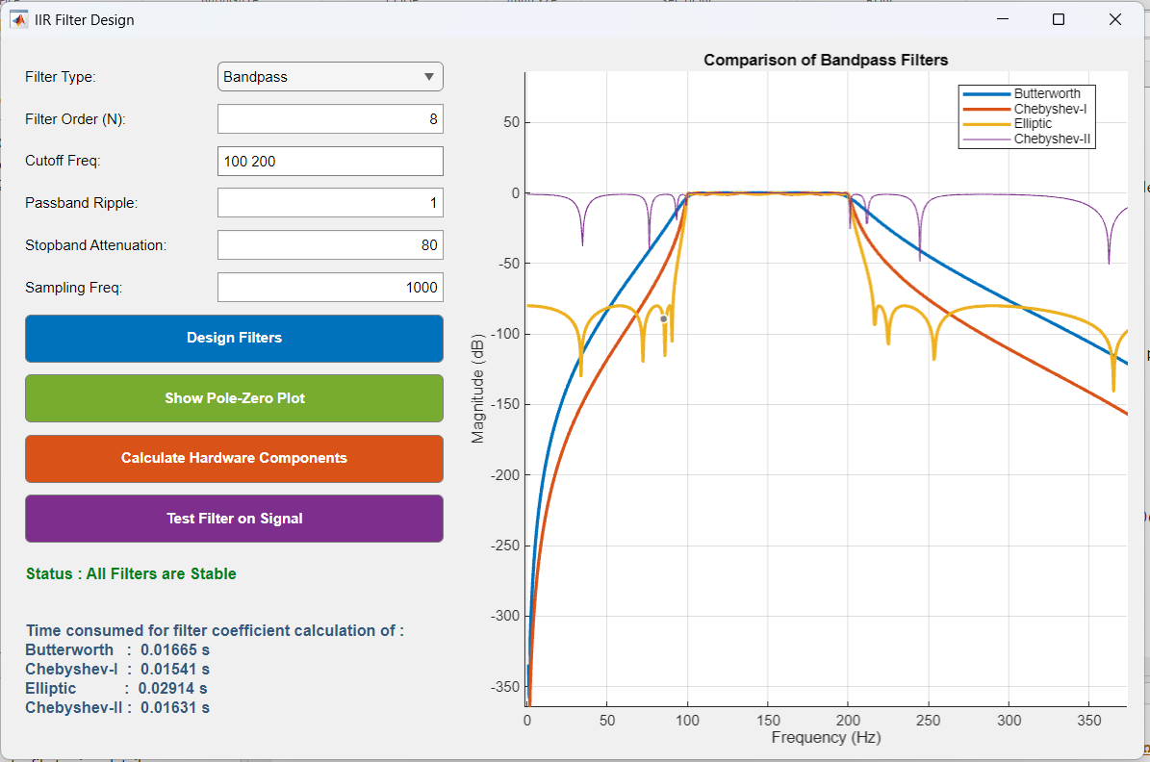
Fig: Bandpass filter Implemented with Passband frequency 100Hz to 200Hz and filter Order 8
Pole Zero plot for Bandpass Filter
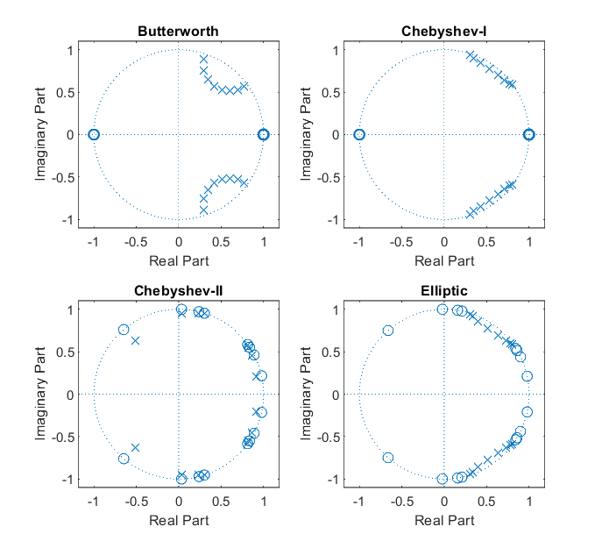
Fig: Pole Zero Plot for Butterworth, Chebyshev 1 and 2, Elliptic IIR Bandpass Filter
Hardware Block calculation For Direct Form I and II Realization
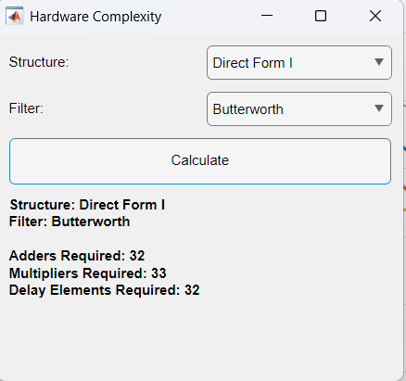
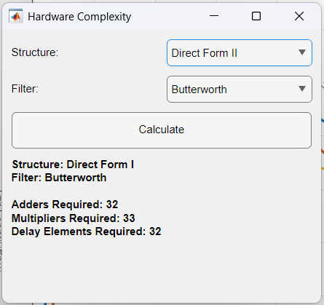
Fig: No. of Hardware Blocks required for Direct Form I and II structure realization of Bandpass Filter with Passband 100Hz to 200Hz and Order 9

Applying The designed filter on a audio signal with added white gaussian noise

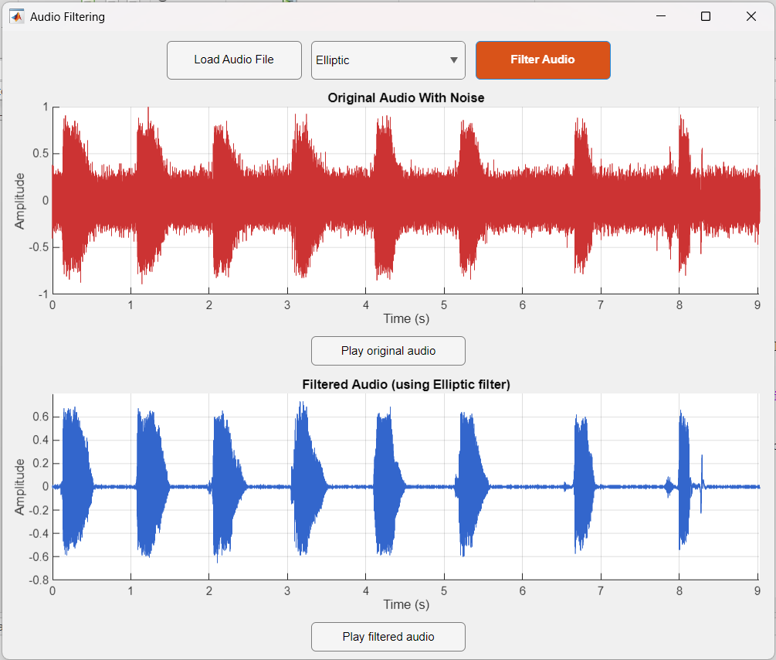
A noisy audio signal filtered through a Lowpass Butterworth IIR Filter of Order 8 and cutoff frequency 150Hz
Result Interpretation:
The results obtained from the MATLAB-based Graphical User Interface (GUI) demonstrate the successful integration of theoretical filter design, stability analysis, and practical signal processing validation. By interacting with the unified front panel, users can dynamically configure parameters and intuitively observe the immediate physical and mathematical impact on the resulting Infinite Impulse Response (IIR) filters.
The following breakdown explains how specific inputs yield the corresponding graphical and numerical outputs:
Magnitude Response Comparison: The initial process begins with the user defining critical filter specifications in the main interface, including the Filter Type, Filter Order, Cutoff Frequency, Passband Ripple, Stopband Attenuation, and Sampling Frequency. For instance, when the user configures a Bandpass filter with an order of 8, a sampling frequency of 1000Hz, and a cutoff frequency range of 100Hz to 200Hz, the system instantly computes the corresponding coefficients. The primary output is a simultaneous plot of the magnitude responses for the Butterworth, Chebyshev-I, Chebyshev-II, and Elliptic filter families. This visual interpretation highlights essential digital signal processing trade-offs: the user can observe that the Butterworth filter maintains the flattest passband, whereas the Elliptic filter provides the sharpest transition band and steepest roll-off.
Stability Verification via Pole-Zero Plot: Upon configuring the parameters, the user can assess system stability by clicking the "Show Pole-Zero Plot" button. The algorithm extracts the roots of the generated numerator and denominator polynomials to map the system's zeros and poles onto a complex Z-plane. The resulting output displays four independent Z-plane subplots. If the user inputs mathematically sound parameters, the visual interpretation will show all poles lying strictly within the unit circle boundary, which triggers the GUI to accurately output a "Status: All Filters are Stable" confirmation.
Hardware Complexity Estimation: To bridge the gap between mathematical design and physical embedded deployment, the user interacts with the "Calculate Hardware Components" module. By selecting a designed filter (e.g., Butterworth) and a desired hardware realization structure (Direct Form I or Direct Form II), the tool algorithmically evaluates the filter order to estimate logic gate requirements. For the implemented Bandpass filter, the output successfully computes the exact hardware blocks required, displaying 32 Adders, 33 Multipliers, and 32 Delay Elements. By toggling the input between Direct Form I and Direct Form II, users can comparatively analyse memory allocation, as the system dynamically recalculates the delay units based on the chosen canonical structure.
Time-Domain Signal Filtering Validation: The final phase of interpretation involves testing the theoretical filter against real-world conditions using the audio testing module. The user loads an external audio file heavily distorted with noise. After selecting one of the actively designed filters (such as the Elliptic filter) and applying it, the system plots both the original and the processed waveforms in the time domain. Interpreting this time-domain response visually confirms the filter's operational success. The user can also play the original noisy audio and filtered audio by pressing the “Play audio” buttons present bellow each plot. The output clearly demonstrates that targeted high-frequency noise components are thoroughly suppressed while the desired fundamental frequencies are extracted and preserved.
- Applications
Control Systems
- PID Controller Tuning
- Vibration Damping
Embedded Systems
- Power Efficiency: Because IIR filters require 1/10th the mathematical operations of an FIR filter, they consume significantly less CPU time, dramatically extending battery life in IoT devices.
- Smart Sensors: Running continuous real-time low-pass filtering on tiny IMU chips
Real-Time Systems
- Bio-Signal Processing: Smoothing noisy ECG/EEG data for immediate diagnostic feedback
- Anti-Aliasing: Acting as a pre-filter to block high-frequency noise right before Analog-to-Digital Conversion (ADC).
- Active Noise Cancellation (ANC)
- Echo Cancellation: Deploying adaptive IIR filters to predict and subtract delayed voice reflections during live video or audio calls.

- Conclusion

In this project, we designed an enhanced Graphical User Interface (GUI) for Infinite Impulse Response (IIR) digital filter design that works robustly for real-time parameter tuning and comparative analysis. The main limitation of standard filter implementation is that it relies heavily on disjointed, script-based manual coding, whereas real-world digital signal processing requires rapid prototyping and immediate visual feedback. To address this, we introduced a unified MATLAB interface that seamlessly consolidates magnitude comparison, automated stability analysis, and physical hardware complexity calculations into a single platform as our novelty.
Our methodology involved capturing user specifications through the GUI, normalizing input frequencies for the digital domain, computing numerator and denominator coefficients for four IIR filter types (Butterworth, Chebyshev-I, Chebyshev-II, and Elliptic), performing stability analysis via Z-plane pole-zero plots, calculating hardware components for Direct Form I and II realizations, and finally testing the designed filter on a noisy audio signal. Performance was evaluated using visual frequency magnitude responses and time-domain signal extraction.
The results achieved confirmed successful and accurate filter generation, with the Elliptic filter demonstrating the sharpest transition and the Butterworth filter maintaining the flattest passband. Waveform analysis showed that the filtering module successfully suppressed the high frequency noise. Visual testing confirmed that the automated Z-plane plots accurately verified system stability by ensuring all poles remained within the unit circle. The system operates efficiently without requiring underlying code modifications, meeting the rapid prototyping requirements for modern digital filter deployment. Applications include bio-medical signal processing (such as ECG smoothing), audio telephony, active noise cancellation, and real-time control systems. Future work includes expanding the tool to support FIR filter design, integrating fixed-point quantization analysis, processing real-time external audio inputs, and generating direct HDL code for hardware implementation on DSP chips or FPGAs.

- Future Scope
While the current graphical user interface provides a robust environment for infinite impulse response filter design and analysis, several potential enhancements can further broaden its utility for advanced digital signal processing applications. The future scope of this project includes the following developmental milestones:
- FIR Filter Integration: Expanding the current capabilities of the graphical tool to fully support the design and analysis of Finite Impulse Response (FIR) filters alongside the existing IIR options.
- Fixed-Point Quantization Analysis: Integrating dedicated computational modules to perform and analyze the effects of fixed-point quantization on the generated digital filters.
- Real-Time Audio Processing: Upgrading the audio signal testing environment to support the capture and processing of real-time external audio inputs, advancing beyond pre-recorded or statically synthesized signals.
- Direct HDL Code Generation: Implementing the functionality to automatically generate direct Hardware Description Language (HDL) code based on the user's configurations. This would significantly streamline the physical hardware implementation of the designed filters directly onto designated DSP chips or Field Programmable Gate Arrays (FPGAs).

- Reference

[1] MATLAB Based Design and Implementation of Digital Filter by Zena Ez Dallalbashi (IJCSNS, Vol. 20 No. 1, January 2020).

[2] The MathWorks Inc., "Create Apps with App Designer," MathWorks Documentation, 2023.

[3] J. G. Proakis and D. G. Manolakis, Digital Signal Processing: Principles, Algorithms, and Applications, 4th ed. Upper Saddle River, NJ, USA: Pearson Prentice Hall, 2006.

